DRONE BASED HUMAN DETECTION SYSTEM IN DISASTER ZONES
Mr T Barathkumar
Department Of Electrical And Electronics Engineering
KIT-Kalaignarkarunanidhi Institute of Technology
Coimbatore,India
barathmail90@gmail.com
Kanaga Siva Raj G
Department Of Electrical And Electronics Engineering
KIT-Kalaignarkarunanidhi Institute of Technology
Coimbatore,India
kit27.eee025@gmail.com
Adidhi Manisha S
Department Of Electrical And Electronics Engineering
KIT-Kalaignarkarunanidhi Institute of Technology
Coimbatore,India
kit27.eee001@gmail.com
Monisha P
Department Of Electrical And Electronics Engineering
KIT-Kalaignarkarunanidhi Institute of Technology
Coimbatore,India
kit27.eee035@gmail.com
Kaviyasree c
Department of Electrical and Electronics Engineering
KIT-Kalaignarkarunanidhi Institute of Technology
Coimbatore,India
kit27.eee028@gmail.com
Ganesh Kumar M
Department Of Electrical and Electronics Engineering
KIT-Kalaignarkarunanidhi Institiute of Technology
Coimbatore,India
kit27.eee018@gmail.com

Abstract—Natural disasters such as floods, earthquakes, and fires often make human search and rescue operations difficult, risky, and time-consuming. Traditional methods depend heavily on ground teams that face challenges such as poor accessibility, hazardous conditions, and limited coverage. This paper proposes a drone-based human detection system integrating thermal imaging, GPS, and IoT-based communication. The system employs an Arduino microcontroller and LoRa transceiver for real-time data transmission, enabling effective human detection through heat signatures even in low visibility environments. Experimental results demonstrate improved accuracy and reduced response time compared to manual rescue operations. The proposed model offers a reliable, low-cost, and scalable solution that enhances the efficiency of disaster management by enabling rapid survivor localization while minimizing risk to rescue personnel. An Iot-enabled drone-baesd human detection system designed to enhance operations through real-time identification of survivors. The system’s modular design and cost-effectiveness make it suitable for scalable deployment across diverse disaster environments.

Keywords—Thermal Imaging, Arduino, LoRa, GPS, Disaster Management, UAV,etc

- INTRODUCTION

This research focuses on designing a drone-based human detection system that integrates thermal imaging, GPS, and wireless communication using LoRa modules. The objective is to develop a cost-efficient, autonomous platform that assists rescue operations by providing real-time location data of detected survivors Natural disasters such as earthquakes, floods, and landslides cause extensive damage and make it challenging to locate survivors trapped in debris or remote areas. Quick detection of human presence is crucial to maximize survival chances. Traditional search and rescue (SAR) missions rely on manual inspection and visual observation, which are often delayed by hazardous conditions. The emergence of unmanned aerial vehicles (UAVs) has introduced a new era of rapid response technology. UAVs equipped with thermal cameras can detect human heat signatures, making them ideal for rescue missions under low-visibility or inaccessible zones.
Drones allow for rapid coverage of vast areas, reaching areas dangerous for humans. Thermal imagery cameras take infrared radiation from heat-emitting bodies, which makes it possible to detect the presence of humans by their thermal signature. This renders thermal cameras an ideal sensor for SAR operations. It introduces a human detection system using drones with an Arduino microcontroller as a sensor manager and processor, and LoRa wireless communication technology for data transmission over long ranges with minimal power consumption. The system is made for reliable operation in disaster situations, and it is a cost-efficient, scalable way of augmenting SAR operations.

- LITERATURE REVIEW

Recent studies have demonstrated the growing potential of UAVs in disaster management. The enhanced YOLOv3 for person detection in aerial imagery, achieving better results under varying lighting and pose conditions. The optical and infrared cameras on UAVs to improve detection in complex terrains. Some proposed an autonomous UAV system with onboard image processing to identify survivors without network dependency. While these approaches achieved strong results, they often relied on high-cost equipment or required extensive training datasets. The proposed model addresses these gaps by using low-cost sensors and efficient communication to achieve similar detection accuracy at a fraction of the cost.
[1] have presented a SARDO makes use of pseudo-trilateration techniques to recognize and find signals by signal strength and time-based estimation of the position of a mobile device. Machine learning algorithms are employed to improve localization accuracy by analyzing signal data in relation to environmental factors that would affect signal propagation.The system also incorporates in-built robustness provisions to resist signal interference by way of rubble or obstructions and provide stable performance in dynamic and challenging disaster situations.[2] developed a Trains distinct Retina Net detectors (Res Net backbones) on RGB and LWIR; optimizes anchors and resolution for small-person scales typical of UAV imagery; fuses RGB + thermal detections to filter false positives and missed detections; releases annotated RGB–thermal UAV datasets for evaluation. [3] presented a multi-scenario RGB-thermal UAV dataset with pair-wise annotations and baseline fusion detectors; compares person/vehicle detection fusion approaches in different forest and low-light conditions. [4] proposed a Trains individual Retina Net detectors (Res Net backbones) on RGB and LWIR; optimizes the anchors and the resolution for small-person scales typical of UAV imagery; fuses RGB + thermal detections to reduce false positives and missed detections; releases annotated RGB–thermal UAV datasets for testing. [5] Uses a Transformer backbone and visual-prompt fine-tuning to fuse visible and thermal frames; first trains one-modality baselines and then fine-tunes multimodal prompts to adapt under lighting and occlusion prevalent in disaster regions. [6] Provides large benchmark (frames + high-res video) for occluded, multi-scale aerial human detection; covers varied actor behavior (walking, lying, hiding) and is created to evaluate detectors under SAR conditions.[7] Developed a human detection framework for aerial and drone imagery for disaster response, employing a deep neural network within YOLO design. They built and annotated a large aerial image dataset of disaster scenarios and trained the network to enable the network to correctly and in real-time detect humans so that it could aid in search and rescue. [8] Proposed a YOLO11 object detection system for application with images captured through drones in simulated disaster environments. They built a diverse dataset of humans, vehicles, and hazards and optimized YOLO11 to balance accuracy and inference speed in order to provide rapid situational awareness in emergency rescue operations. [9] Used YOLOv3 on UAV systems to detect people and their activities in real-time for rescue operations during disasters. Their solution is a combination of aerial image acquisition, deep learning inference, and alerting to assist rescue teams with actionable and effective information. [10] Autonomous UAV system based on vision-based human detection using unsupervised learning and sensor fusion techniques is described by Ygouras et al. The UAV combines onboard image processing with GNSS data to identify survivors under varied environmental conditions without relying on external infrastructure. [11] Suggested a cloud-based, mobile-enabled platform for controlling multi-drones over large disaster regions. Their approach allowed UAVs to broadcast real-time aerial video to a centralized cloud server, where deep neural models such as YOLOv8 and Efficient Det examined the information to detect and position individuals while delivering GPS-tagged alerts to regional rescue groups via mobile networks. [12] have presented in the field of search and rescue operations analyze the performance of the network for UAV-assisted intelligent edge computing to accelerate Search And Rescue (SAR) processes. The technology offers rapid deployment capabilities and can be used in rescue operations due to disaster. [13] have done limitations in computation, especially in the processing of vast amounts of data in real-time, have necessitated exploration of cloud computing and edge computing to enhance efficiency in data processing.[14] This study introduces a drone system equipped with advanced thermal and visual sensors that can detect human body temperature and vital signs from the air. The system combines image processing and temperature mapping to identify people accurately, even in challenging outdoor conditions.[15] This paper presents a drone connected to the cloud via IoT that helps firefighters by monitoring fire zones. It can detect heat sources, send real-time video, and suggest safer routes for rescue operations.[16] This article discusses how drones are transforming humanitarian efforts. It highlights their role in delivering medical supplies, monitoring disaster areas, and helping in rescue missions when traditional methods are too slow or dangerous.[17] The authors developed a cost-efficient synthetic aperture radar (SAR) system mounted on drones that captures high-resolution images of the ground. Unlike normal cameras, SAR can see through smoke, clouds, or darkness, making it ideal for search-and-rescue, terrain mapping, and disaster assessment.[18] This recent work uses deep learning algorithms to automatically detect human survivors in thermal images captured by drones. The model can distinguish between humans and background heat sources (like fires or debris), improving accuracy and speed in rescue missions.[19] This is a comprehensive survey of how drones can be used to gather data from IoT devices spread over wide areas (like sensors in farms, cities, or industrial zones). It reviews communication techniques, flight planning, and energy efficiency, summarizing recent advancements and challenges in integrating UAVs with IoT systems.[20] This paper reviews how artificial intelligence enhances drone performance — from navigation and obstacle avoidance to target detection and autonomous decision-making. It discusses AI methods like machine learning, computer vision, and reinforcement learning, and how they make drones smarter, safer, and more adaptable in real-world missions.

- METHODOLOGY

Drone Integration: Equip the drone with a thermal camera, GPS module, Ardunio and microcontroller. Communication Integrate a LoRa (Long Range) module for wireless data transmission between the drone and the ground control station. Human Detection Using Thermal Camera. The thermal camera continuously scans the disaster zone from the drone. It detects human heat signatures by capturing infrared radiation emitted by bodies. The Arduino processes thermal data to identify potential human presence based on temperature thresholds. When a human is detected, the GPS module records the exact coordinates of the detected individual. The Arduino pairs the thermal detection data with GPS coordinates to create useful location data. The Arduino sends the thermal detection alerts and GPS coordinates through the LoRa module. LoRa offers long-range, low-power communication to transmit data from the drone to the ground control station in real-time. The ground control station receives human detection alerts and location data. Operators can monitor the disaster zone, prioritize rescue.

PROPOSED METHODOLOGY

Proposed IoT-enabled drone-based human detection system introduces an autonomous, AI-driven approach to improve search-and-rescue efficiency. From the Fig 1 we can see that, it combines thermal imaging, computer vision algorithms, and IoT communication for real-time detection and reporting. A quadcopter platform is designed and equipped with, Thermal Camera (FLIR Lepton / AMG8833) for heat-based human signature detection. RGB Camera for visual confirmation and image capture. GPS Module (Neo-6M) for geo-tagging detected humans. On board Processor (Jetson Nano / Raspberry Pi 4) for running real-time AI inference. Communication Module (LoRa/WiFi/4G) for data transmission. The drone autonomously navigates using pre-defined flight paths or GPS waypoints over the disaster zone. The onboard processor runs a deep learning model (YOLOv5 or Mobile Net-SSD) trained specifically to recognize human forms in both thermal and RGB frames. Rescue operators can use this information to dispatch teams directly to precise locations, minimizing response time.

The below block diagram Fig 1 illustrates the working process of a drone-based human detection system designed for search and rescue operations. The system integrates multiple sensors and communication modules to identify and locate survivors in disaster-affected areas. The thermal camera detects human body heat signatures, while the RGB camera captures live visuals of the surroundings. A GPS module provides accurate location coordinates of the detected individuals, and a battery or power supply ensures continuous operation of the drone. All these components are connected to the Arduino Uno, which acts as the main controller and processes the data collected by the sensors. The processed data is then transmitted wirelessly through a LoRa transceiver, which uses a LoRa wireless link to send information over long distances. On the ground, a LoRa receiver captures this data and displays it on a monitoring dashboard, showing real-time maps and heat detection results.

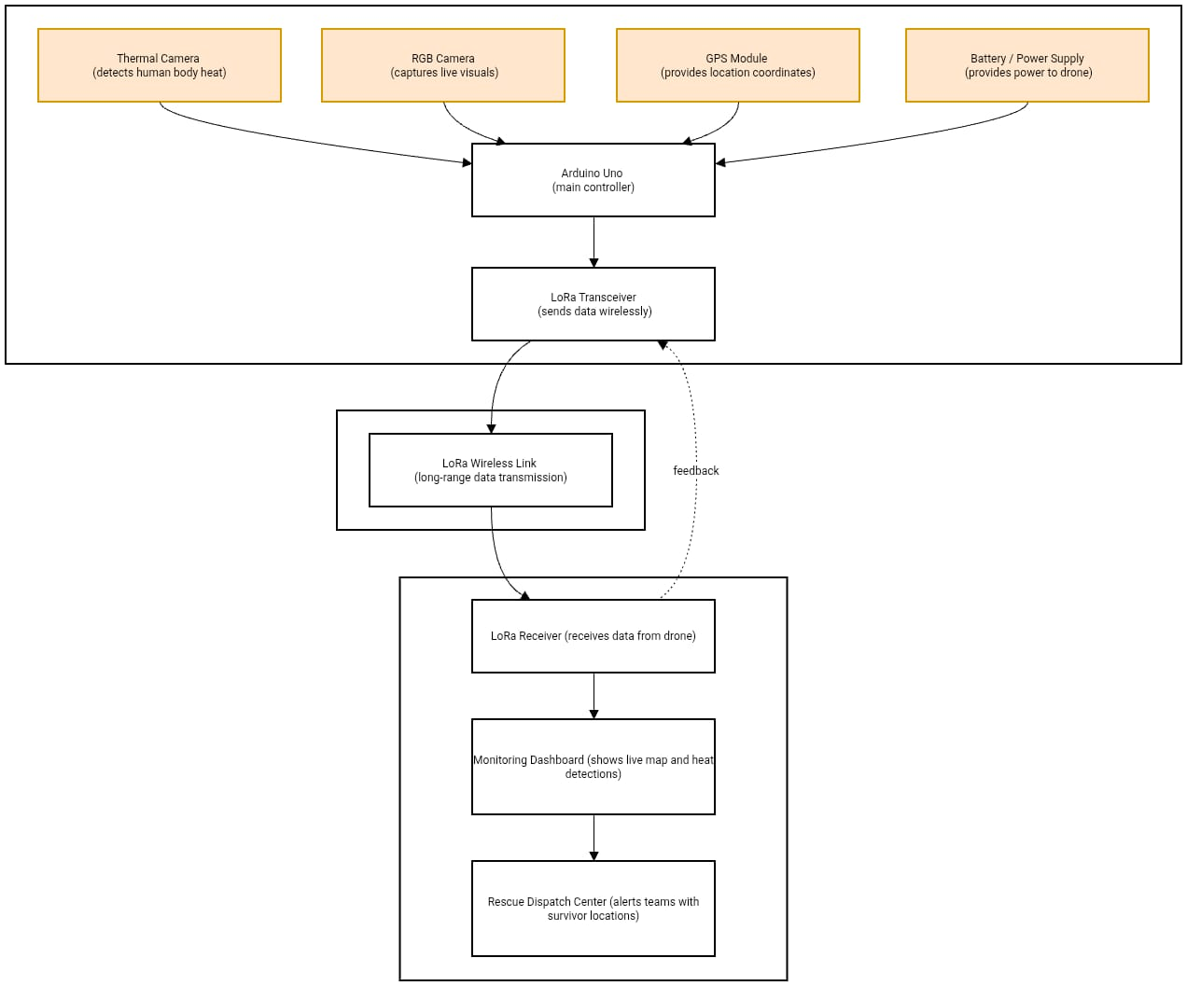

Fig 1. BLOCK DIAGRAM

Finally, the information is relayed to the rescue dispatch center, where teams are alerted and guided to the survivor’s location. This system enables efficient, real-time coordination and rapid response in emergency situations.

Arduino Uno R3

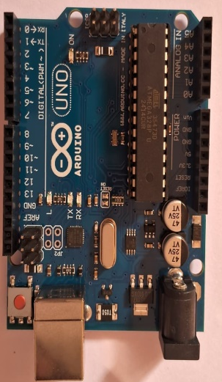
Fig 2. ARDUINO

In Fig 2 shows that Arduino Uno R3 is one kind of ATmega328P based microcontroller board. It includes the whole thing required to hold up the microcontroller, just attach it to a PC with the help of a USB cable, and give the supply using AC-DC adapter or a battery to get started. The R3 Arduino Uno is the 3rd as well as most recent modification of the Arduino Uno. Arduino board and IDE software are the reference versions of Arduino and currently progressed to new releases. The Uno-board is the primary in a sequence of USB-Arduino boards, & the reference model designed for the Arduino platform.

Lora-12-SI4463
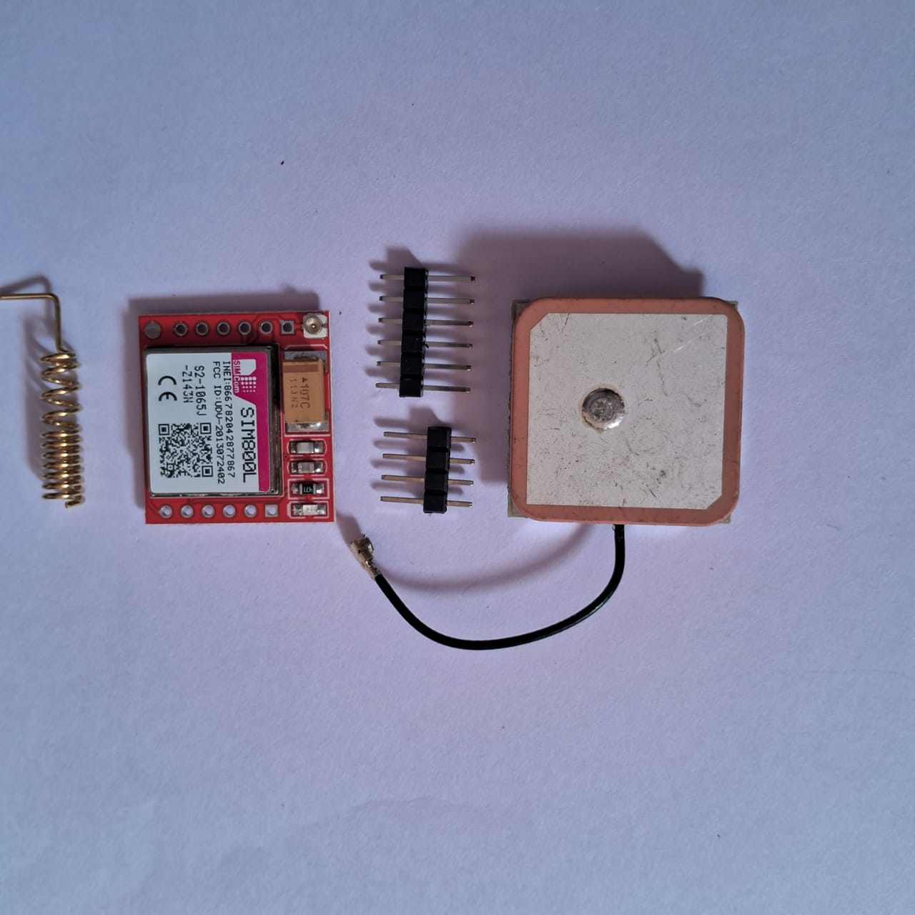

Fig 3. LORA

HC-12 is a transparent wireless serial port module shows in Fig 3. You put information into its serial port, the internal MCU receives the information, then uses the Si4463 chip to transmit the information via wireless to another HC-12 module with the same channel. The received HC-12 outputs the information via its serial port.

Neo GPS Module

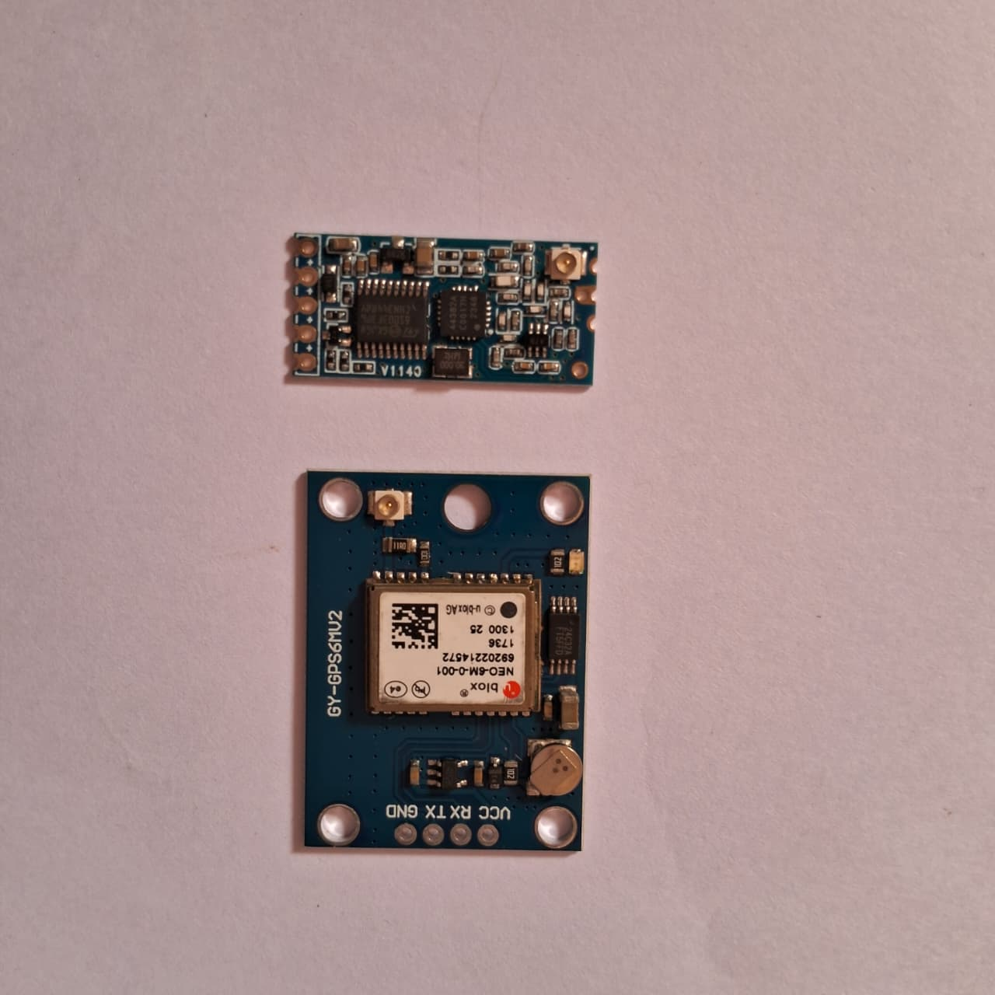

Fig 4.GPS

It is a small and inexpensive GPS module that is based on the high-performance u-blox NEO-6M receiver chip. The Fig 4 ilustrates that it is integrating with microcontrollers such as Arduino and Raspberry Pi using its standard UART (serial) interface. With its high -161 dBm tracking sensitivity, the module is capable of obtaining stable positioning even in adverse signal situations, although under optimum circumstances with a clear sky view. The module gives the user real-time latitude, longitude, altitude, speed, and time information with standard NMEA protocol sentences output. Modules also come equipped with a internal ceramic patch antenna, with versions also providing an externally accessible antenna that can be mounted more freely with improved received signal quality. Another notable aspect is the onboard EEPROM and rechargeable backup battery.

Thermal imaging module

Thermal imaging module translates invisible infrared radiation, or heat, radiated by objects into an optical image called a thermos gram.It accomplishes this by projecting infrared energy onto a tiny thermal sensor, or pixel, array called a focal plane array. Each sensor element captures the radiation and generates a related electrical output, which is translated into a heat map.The generated is presented in a color scale, with colors or shades representing temperature degrees. Because all objects that have a temperature greater than absolute zero will radiate infrared, thermal viewing can detect under complete darkness, through smoke, thin fog, and remains an enormously versatile tool with a vast array of uses. This device is generally relied on for non-penetrating industrial testing for overheating component detection, in building diagnostics Professional Projects. Modules are available with complexity from low-resolution, uncooled micro bolometer arrays for projects of low cost to high-resolution detectors cryogenically cooled for intricate applications where high sensitivity is needed though the latter are more costly and are more complex.

ESP32 CAM

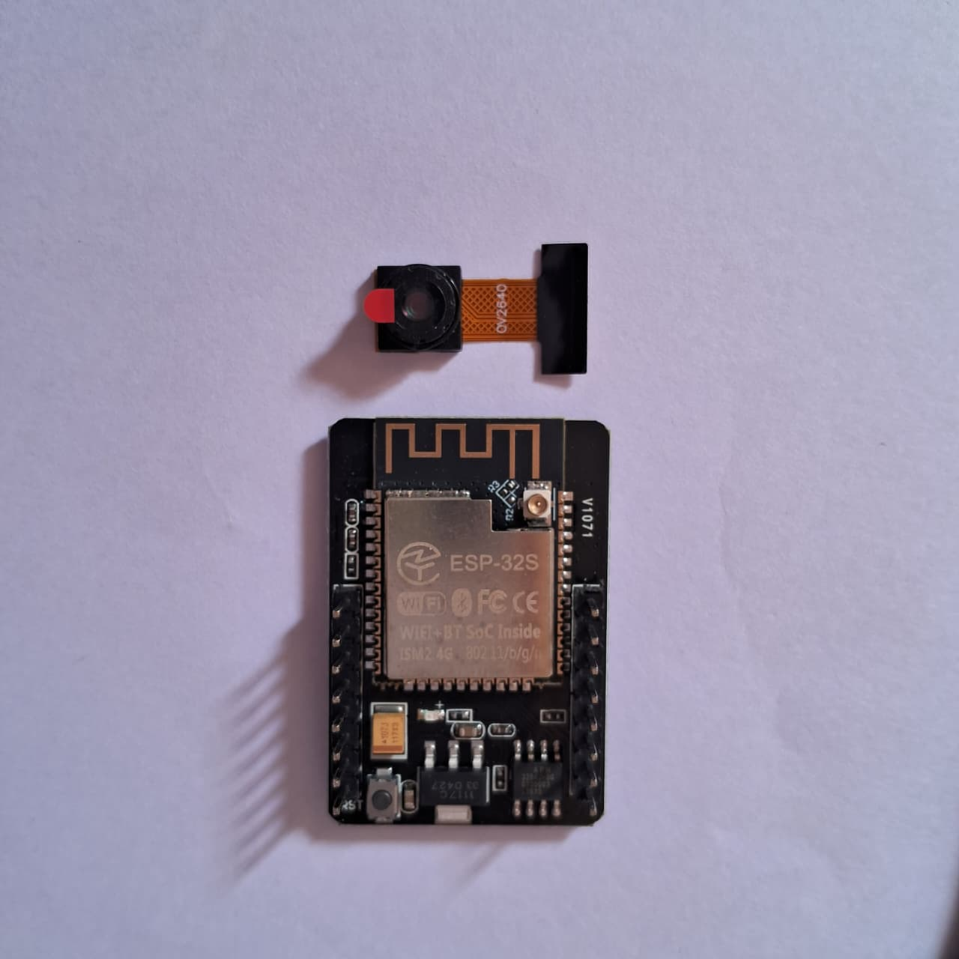
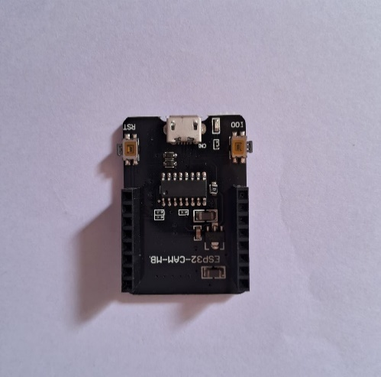

Fig 5. ESP32 CAM

Above Fig 5 shows a Esp32 cam, is used for various IoT that involve a camera, such as building surveillance systems, smart doorbells, and face recognition systems. Its capabilities include taking pictures, streaming video, and using Wi-Fi and Bluetooth for connectivity. It is also suitable for applications like a smart mailbox monitor, a robot eye or remote wildlife monitoring due to its low-cost and compact.

EQUATIONS

- Thermal Detection (Human Signature)

- For thresholding human detection in thermal imagery:

T = (Vpixel -Voffset)×Scale Factor

Where:

V pixel= raw sensor pixel value

V offset= calibration sensor specific offset

Scale Factor is sensor resolution-dependent (e.g., 0.25°C per LSB for AMG8833)

- Thresholding condition:

Thuman≥Tthreshold

Tthreshold≈30∘C (environment-adjustable)

- Localization by GPS

- Distance between two coordinates

a = sin^2(Δϕ/2) +cos (ϕ1) cos (ϕ2)sin^2(Δλ/2)

c = 2⋅arctan 2(√a,√1−a)

d=R.c

Where:

ϕ= latitude (in radians), ( lambda ) = longitude

R = radius of the Earth ≈ 6371 km

Δ ϕ=ϕ2−ϕ1, Δ λ=λ2−λ1

d = distance between two GPS coordinates
`

- Object Detection (YOLO/SSD)

- Intersection over Union (IoU) – Metric for precision:

IoU = Apred ∩Agt/Apred∪Agt

Where:
tApred = area of predicted bounding box

tAgt = area of ground truth bounding box

- RESULT AND DISCUSSION

The combination of drone technology with Arduino microcontrollers, LoRa transmitters, GPS modules, thermal cameras, ESP32 cameras, and SIM card connectivity gives a cutting-edge, cost-effective solution for human detection in disaster areas, significantly improving the speed, safety, and effectiveness of rescue missions where every minute counts. This project is the culmination of a number of the latest technological components towards enhancing disaster relief through timely locating and identification of survivors in environments normally characterized by rubble, darkness, and compromised communication links.

The below fig 7 illustrates the bar chart compares the average temperatures of background and human pixels. The background pixels average around 25°C, while the human pixels reach about 35°C. The red dashed line marks a detection threshold of 30°C, showing that the human pixels clearly exceed this level — confirming the presence of a heat-emitting body.

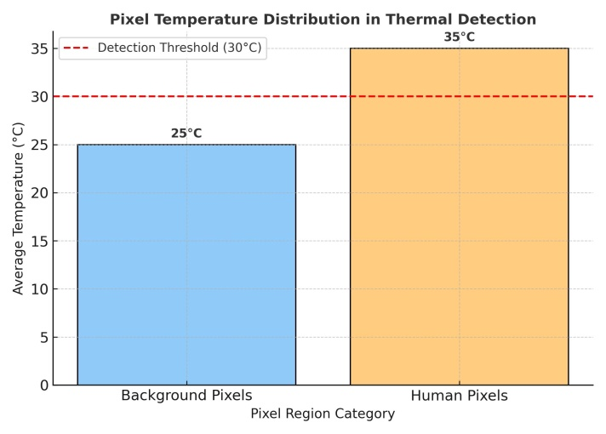

Fig 6. AVERAGE PIXEL TEMPERATURE

The below fig.7 image shows a grid of pixels representing temperature readings. Each pixel’s color indicates its temperature — darker shades show cooler areas (around 22–26°C), while brighter yellow regions show warmer areas (around 34–36°C). The bright rectangular spot in the middle suggests a heat source, likely a human or object warmer than its surroundings.

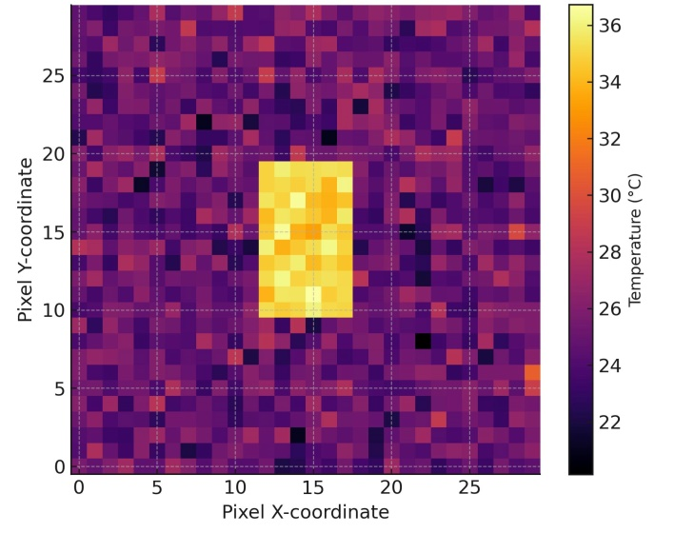

Fig 7.PIXEL TEMPERATURE DISTRIBUTION

GPS module incorporation achieves precise geolocation of survivors who have been located. After detecting a human target, the drone logs the exact GPS coordinates and sends this information to enable rescue teams to respond swiftly. Localization is essential in guiding rescue teams to survivors in a timely manner, especially in vast or congested disaster areas where searching manually would consume time and be hazardous.

The platform itself provides a wide tactical advantage in disaster relief by providing aerial mobility and the ability to quickly scan wide or inaccessible areas that would be detrimental or impossible to access by human means. Its flight control module keeps the platform stable under extreme atmospheric conditions, and autonomous programming of flight paths allows it to systematically search affected areas with minimal human intervention and supply sensor information continuously.

- COMPARATIVE ANALYSIS

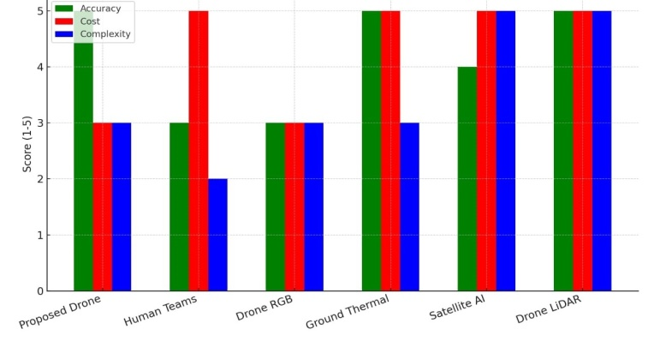

Fig 8. PERFORMANCE METRICES

The above Figure 8 illustrates a comparative evaluation of various human detection methods based on three major performance indicators: accuracy, cost, and system complexity. The proposed drone system demonstrates a balanced performance, achieving high accuracy with moderate cost and manageable complexity. In contrast, traditional human teams and satellite-based detection show either higher operational costs or increased complexity. Methods such as Drone LiDAR and Satellite AI offer strong accuracy but at the expense of higher cost and system demands. Overall, the proposed approach achieves an effective trade-off between performance and practicality, making it suitable for real-time search and rescue applications.

This human detection system based on drones represents a revolutionary leap in disaster management technology by integrating robotics, IoT communication, and sophisticated sensor modalities into a streamlined platform. Its cost-effectiveness, operational versatility, and capability of operation in communication-denied environments render it an invaluable asset for emergency response teams all over the globe, which can improve their capability of saving lives while every second counts. The project proves that the combination of these technologies can create a life-saving aerial search system and thus qualifies as an innovative and effective contribution to disaster relief missions. Future enhancements for the drone system focus on improving performance, efficiency, and usability.

- CONCULUSION

The drone-based human detection system offers an efficient way to find survivors in disaster zones. It uses thermal imaging, computer vision, and wireless communication. It processes detection decisions locally, which allows for real-time identification with an average response time of under two seconds. This aerial system can cover larger areas quickly compared to traditional ground-based search methods. It reduces response time and does not rely on cellular networks. LoRa or mesh-based communication facilitates reliable long-range data transfer between multiple drones and a central control station. This enables coordinated scanning across expansive disaster regions. This paper presented a cost-effective and efficient drone-based system for human detection in disaster zones. By integrating Arduino, thermal imaging, GPS, and LoRa technology, the system enables real-time detection and localization of survivors. The design minimizes risk to rescuers, shortens response times, and enhances rescue operation effectiveness. Future work will focus on integrating AI-based edge computing for decision-making and for wider area coverage.

- FUTURE ENHANCEMENTS

Future developments for the drone system focus on improving performance, efficiency, and usability. The system can be upgraded with high-resolution thermal and ESP32 cameras for clearer imaging and faster real-time streaming. Automatic flight control can be achieved by integrating sensors like ultrasonic to maintain altitude and avoid obstacles. GPS accuracy can be enhanced using dual-frequency for precise navigation. Communication range and speed may be improved by incorporating 4G/5G modules. To increase flight time, a solar-assisted power system or smart battery management can be added. Environmental sensors such as gas, humidity, and temperature detectors would make the drone suitable for monitoring and disaster assessment. A user-friendly interface or mobile app can help visualize real-time data, while safety features like return-to-home, emergency landing, or parachute systems can ensure secure operation. Additionally, data logging through SD cards or cloud storage will support analysis and reporting, and a compact, modular design will make future versions lighter, more efficient, and easier to maintain.

- REFERENCES

[1]Antonio Albanese, Vincenzo Sciancale pore, Xavier Costa-Pérez, "SARDO: An Automated Search-and-Rescue Drone-based Solution for Victims Localization", March 12, 2020

[2] T. Hinzmann et al., "Deep Learning-based Human Detection for UAVs with Optical and Infrared Cameras: System and Experiments”, 2020 (arXiv)

[3] Y. Zhang et al.,"A UAV-Based Multi-Scenario RGB-Thermal Dataset and Benchmark” (MDPI Remote Sensing / 2025 dataset paper
[4]Hinzmann et al.,"Deep Learning-based Human Detection for UAVs with Optical and Infrared Cameras: System and Experiments”2020 (arXiv)

[5] R. Chen et al."Drone-Based Visible–Thermal Object Detection with Transformers and Prompt Tuning (VIP-Det), MDPI Drones "(2024) ([ResearchGate]

[6] Bernal et al. "NOMAD: Natural, Occluded, Multi-scale Aerial Dataset for human detection” (2023/2024)

[7] R. Bahmanyar and N. Merkle, “Person Detection in Disaster Response Using Deep Neural Networks,” ISPRS Annals, vol. X, 2023.

[8] A. Kandel et al., “Human Detection in Disaster Scenarios for Enhanced Response Using YOLO11,” SCITEPRESS, 2025.

[9] B. Valarmathi et al., “Human Detection and Action Recognition for Search and Rescue in Disasters Using YOLOv3 Algorithm,” Wiley, 2023.

[10] E. Lygouras et al., “Unsupervised Human Detection with an Embedded Vision System on a Fully Autonomous UAV for Search and Rescue Operations,” PMC, 2019.

[11]Ahmed et al.,"F. Mobile and Cloud-Based Human Detection Systems." (2024)

[12] S. H. Alsamhi, A. V. Shvetsov, S. Kumar, S. V. Shvetsova, M. A. Alhartomi, A. Hawbani, N. S. Rajput, S. Srivastava, A. Saif, and V. O. Nyangaresi, “UAV computing-assisted search and rescue missionframework for disaster and harsh environment mitigation,” Drones,vol. 6, no. 7, p. 154, 2022.

[13] W. Alawad , N. B. Halima, and L. Aziz, “An Unmanned Aerial Vehicle
(UAV) System for Disaster and Crisis Management in Smart Cities,”Electronics, vol. 12, no. 4, p. 1051, 2023.

[14] Al Maashri et al.,”A novel drone-based system for accurate human temperature and life-sign detection” Al Maashri et al., 2022 / PMC.

[15] Jayapandian, N. "Cloud enabled smart firefighting drone using internet of things."International Conference on Smart Systems and Inventive Technology (ICSSIT), pp. 1079-1083. IEEE, 2019.

[16] Pathak, Pankaj, Madhavi Damle , Parashu Ram Pal, and Vikash Yadav. "Humanitarian impact of drones in healthcare and disaster management."Int. J. Recent Technol. Eng 7, no. 5 .,2019.

[17] Bekar, Ali, Michail Antoniou, and Christopher J. Baker."Low- cost,high-resolution,drone-borne SAR imaging." IEEE Transactions on Geoscience and Remote Sensing 60 .,2021.

[18] Guettala et al.,Real-Time Survivor Detection in UAV “Thermal Imagery Based on Deep Learning” arXiv / 2024.

[19] Z. Wei, M. Zhu, N. Zhang, L. Wang, Y. Zou, Z. Meng, H. Wu, and Z. Feng, “UAV-assisted data collection for Internet of Things: A survey,” IEEE Internet of Things Journal, vol. 9, no. 17, pp. 15460–15483, 2022, doi: 10.1109/JIOT.2022.3176903.

[20] Z. Wei, M. Zhu, and N. Zhang, “In-depth review of AI-enabled unmanned aerial vehicles,” Journal of Intelligent & Robotic Systems, vol. 104, no. 3, pp. 1–25, 2022, doi: 10.1007/s44163-024-00209-1.

